LAVA LAMPS AND THE CONVECTION CURRENTS IN THE EARTH

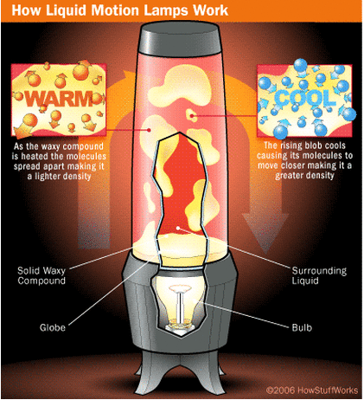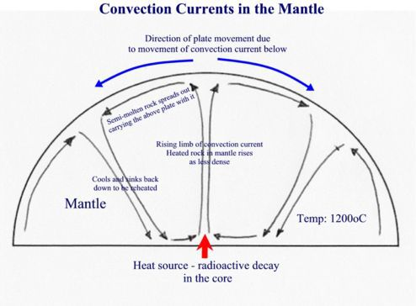

The Earth's mantle has convection currents because the heat of the core

acts similarly to the light bulb in our lava lamp.  The core's heat energy is

transferred to the mantle, causing it to rise towards the Earth's surface, which is cooler.  As the heated mantle transfers its heat energy to the lithosphere, it becomes more dense than the surrounding magma and sinks back down towards the core.

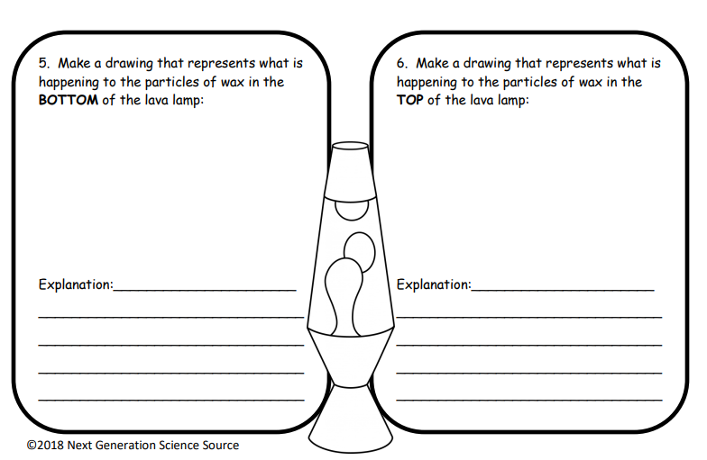

**1.**

**2.**

3. Make a drawing that illustrates what is happening to the mantle near the Earth’s core:

4. Make a drawing that illustrates what is happening to the mantle near the Earth’s crust (causing it to sink back to the core):

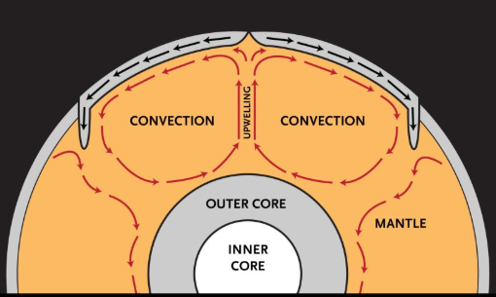

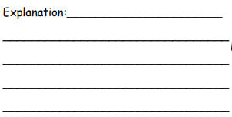



**Lava Lamps & Convection Currents in the Earth**

|  |
| --- |
| **Step 1**:  Read and study the diagrams of the lava lamp convection currents and the convection currents in the Earth’s interior. Visually compare the two diagrams. (Hint: look at what is happening close the “light” (heat) in the lamp and compare this to what is happening close the “core” (heat) in the Earth. As the lava rising to the top of the lamp what happens to the particle’s movement, compare this to the movement of the particles near the Earth’s crust. |

|  |
| --- |
| **Step 2**:  In Question #1 & 2 – refer to the picture of the lava lamp, as you are making your drawing consider the “density” – or how close or far apart the particles are. Illustrate this in your drawing. |

|  |
| --- |
| **Step 3**:  In Question #3 & 4 – refer to the picture of the Earth’s Interior, as you are making your drawing consider the “density” – or how close or far apart the particles are. Illustrate this in your drawing. (Hint: remember the top of the lava lamp is like the top of the crust, and the bottom of the lava lamp is like the core. |

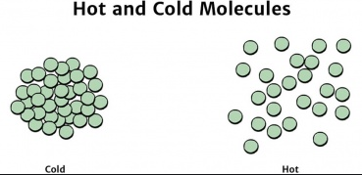Use this diagram to assist your drawings: